ABAP Data Dictionary

1. Transaction code – SE11

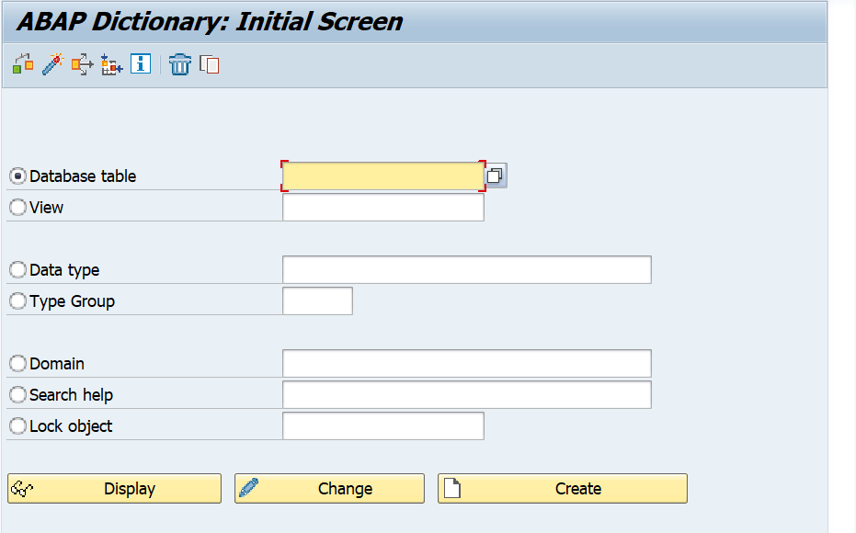

let's go through the different options that we see on the screen. The first one we see is Database Tables. This is where we can enter an existing table name, followed by a display to have a look at the technical components of the table.

Then we have views, a view is like a table, but all it is, is a table structure, it doesn’t contain any data. Then we have data types.

Data types are what can make up our database tables

1. In the database tables field, enter ZYNY_AS_EMPLOYEE. And click the create button

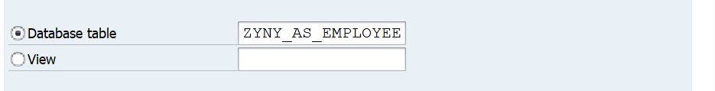

1. Click on create button

in this exercise, we're going to focus on creating a transparent table. There are other types of tables such as Calista tables and pool tables. But you don't need to know about those just now. All we want to do is create a transparent table. And when we create our table, we need to ensure our table name adheres to the customer defined namespace. And this means we need to start our tables with the letter Z or the letter Y.

1. Enter description.

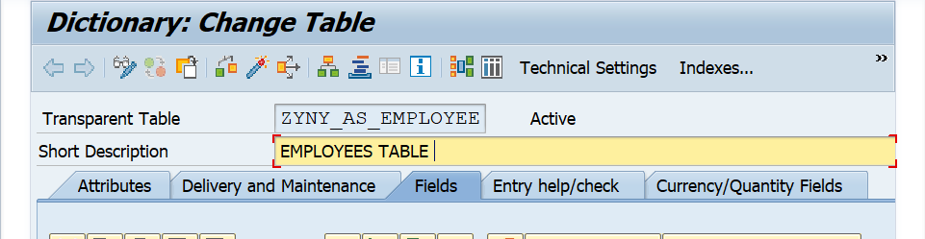

This new screen appears, and the cursor is on the short text field, all we need to do here is enter a description for our table.

1. In Delivery Maintenance tab, enter data

Just type in employees. Now under the short text you can see various tabs. And the one that's highlighted at the moment is the Delivery Maintenance tab.

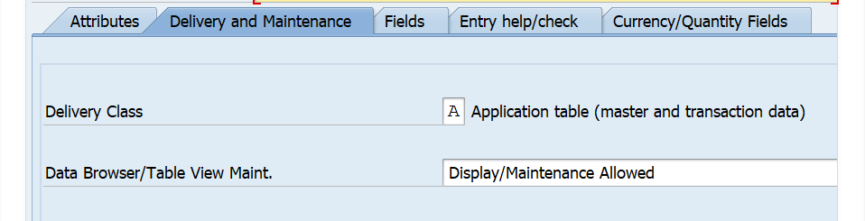

For the delivery class, click on the field, and click the drop-down button. This shows you a list of delivery classes that you can choose for your table. Have a read through, but the one we want to choose is Application Table. Because we're going to hold master data or transaction data in the table that we are creating.

And in the Data Browser/Table View Maintenance field, click the drop down again, and choose Display Maintenance Allowed. This will allow us later to enter data directly into the table.

1. click the save button.

Now this window pops up.

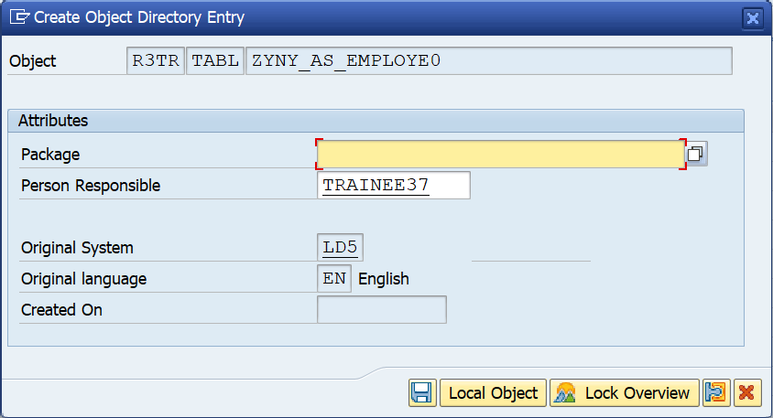

Create Object Directory Entry. Now what this is all about, is any development we do within the SAP system, quite often we do the development in our development environment, and we must move the development through to our quality assurance environment, and then through to production. And this window allows us to choose the development class which has config behind it, the actual transport routes that we want to use for our development.

1. Now enter the package name, in which you want to save the report
2. go to the Go To menu and choose Object Directory Entry, we can then see the Change Object Directory Entry pop-up box, which is very similar to the previous one and we can see that the development class has been changed to entered package name.